

**CSE303: Statistics for Data Science**

**[Summer 2023]**

**Report on Assignment 01**

**Data Visualization**

**Submitted by**

**Student ID:** Nisarga Mridha

**Student Name:** 2020 – 2 – 60 – 010

# Introduction

The data visualization assignment was on visualizing a given dataset of salaries of 6704 people (including male, female, and others). Along with gender and salaries, the dataset has the data of Years of Experience, Job Title, and Education Level of those 6704 people. To visualize the data I have used some common visualization techniques. They are Bar Chart, Box and Whisker Plot, Histogram, and Scatter Plot. Although there are many other visualization techniques I could use. Anyway, I have used some built in python libraries to do the assignment. They are matplotlib and seaborn library.

# Dataset Characteristics

As already mentioned, the given dataset has 6704 rows in it. And also it has 6 columns. They are Gender, Age, Years of Experience, Job Title, Education Level, and Salary. Gender column has 3 individual entries (Male, Female, and Others). Age column has data which are in between 21 to 60. Years of Experience also hase the same range as Age. Job Title has 132 unique entries such as Software Engineer, Data Engineer, etc. Education Level has 4 unique entries. Though the main dataset has duplicate entries with different name which has been fixed. The entries are High School, Bachelor’s, Master’s, and PhD. And finally, the Salary has a range between 500 to 220,000.

The dataset has been collected from Kaggle. Link: [Salary_Data | Kaggle](https://www.kaggle.com/datasets/mohithsairamreddy/salary-data)

# Exploratory Data Analysis

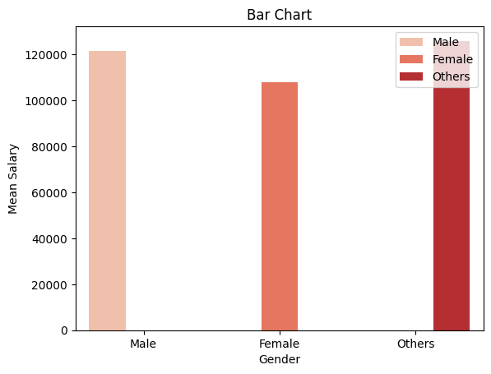

*figure 1. Bar Chart of Average Salary of All Genders*

**Explanation:**

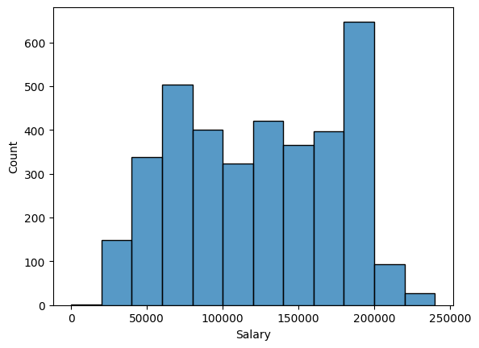

***figure 2. Histogram for Salary of Male Employer***

**Explanation:**

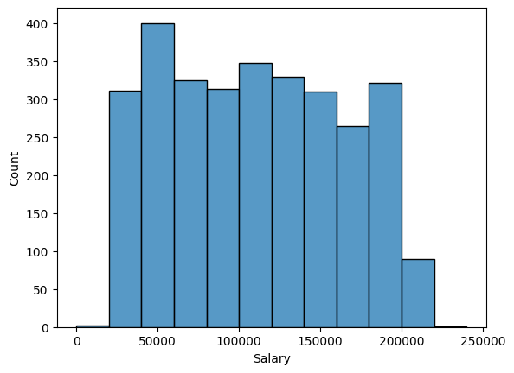

***figure 3. Histogram for Salary of Female Employer***

**Explanation:**

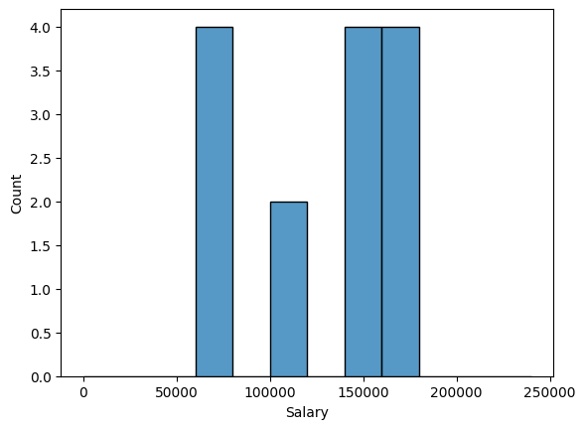

***figure 4. Histogram for Salary of Employer Other than Male and Female***

**Explanation:**

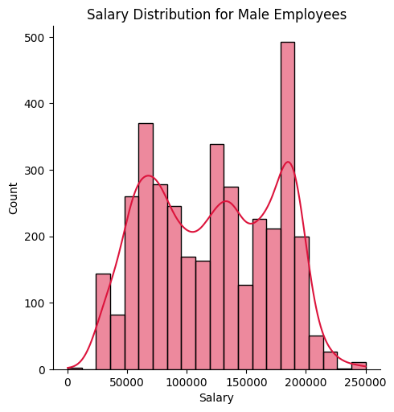

*figure 5. Histogram of Salary Distribution of Male Jobholders*

**Explanation**:

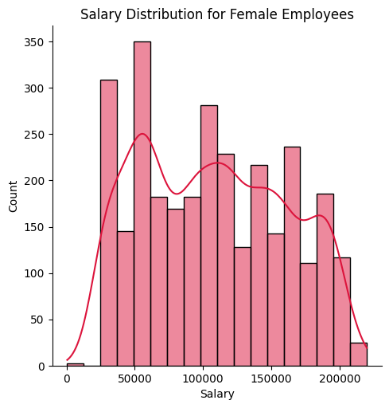

*figure 6. Histogram of Salary Distribution of Female Jobholders*

**Explanation:**

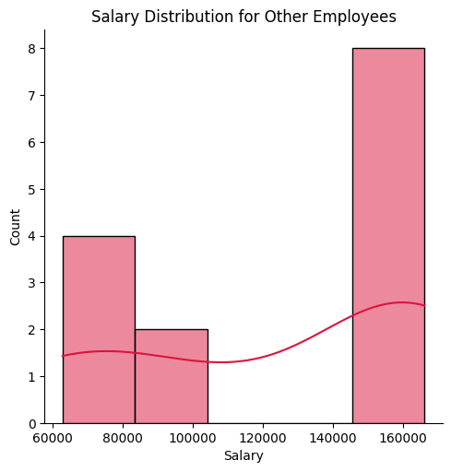

*figure 7. Histogram of Salary Distribution of Other than Male and Female Jobholders*

**Explanation:**

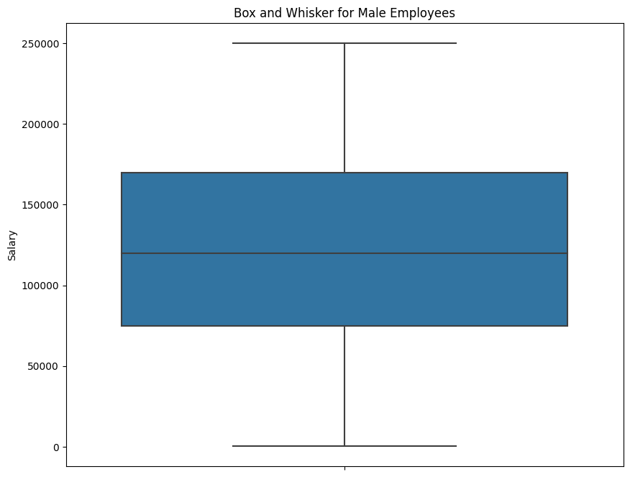

*figure 8. Box and Whisker Plot for Salary Distribution for Male Employees*

**Explanation:**

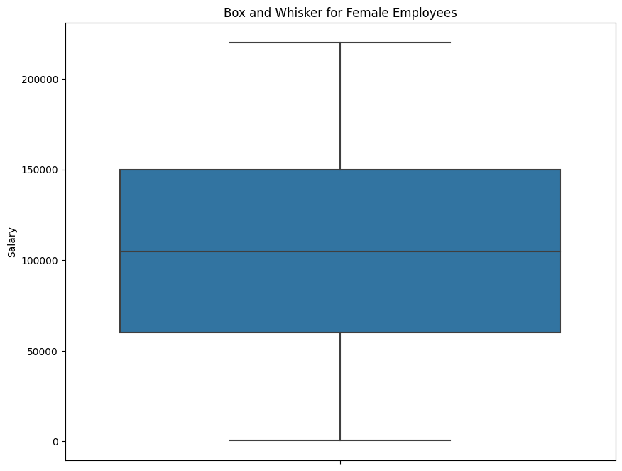

***figure 9. Box and Whisker Plot for Salary Distribution for Female Employees***

**Explanation:**

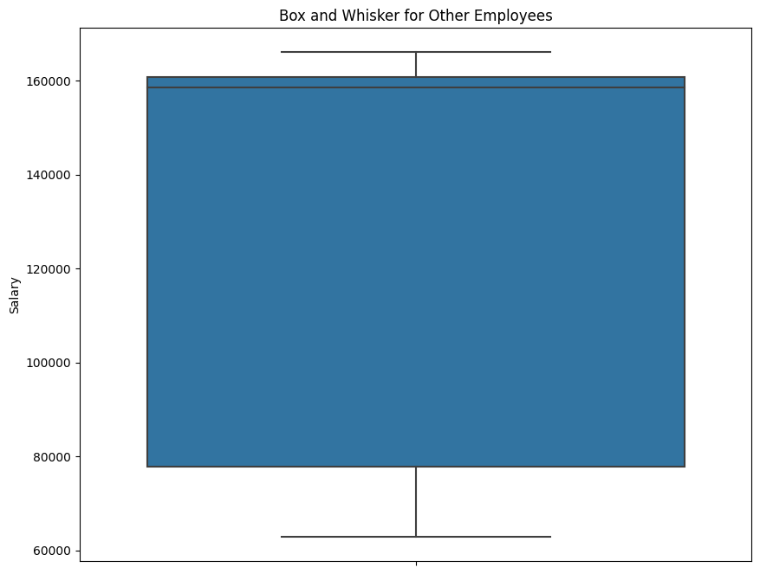

***figure 10. Box and Whisker Plot for Salary Distribution for Other Employees***

**Explanation:**

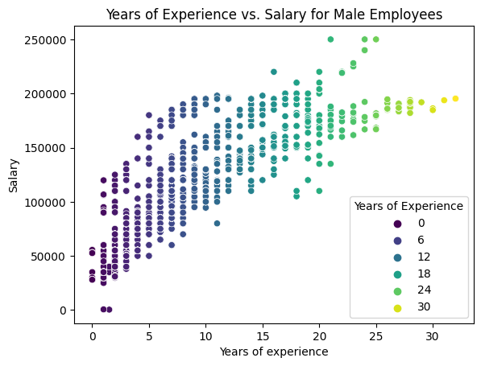

***figure 11. Scatterplot for Years of Experience vs. Salary for Male Employees***

**Explanation:**

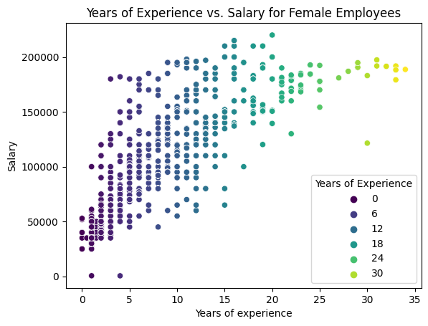

***figure 12. Scatter Plot for Years of Experience vs. Salary for Female Employees***

**Explanation:**

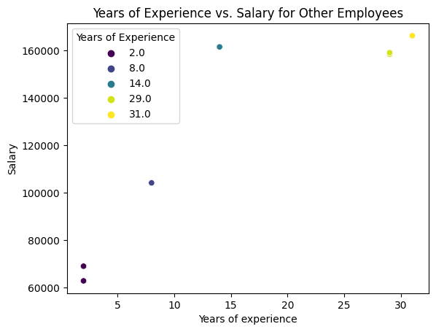

***figure 13. Scatter Plot for Years of Experience vs. Salary for Other Employees***

**Explanation:**

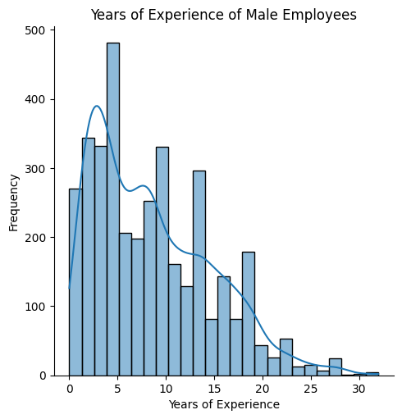

***figure 14. Histogram for Years of Experience of Male Employees***

**Explanation:**

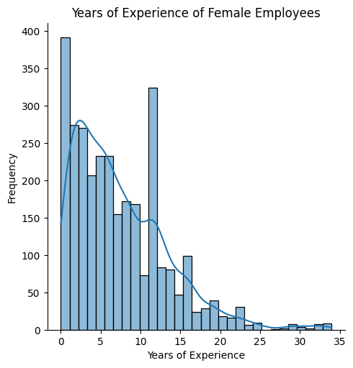

***figure 15. Histogram for Years of Experience of Female Employees***

**Explanation:**

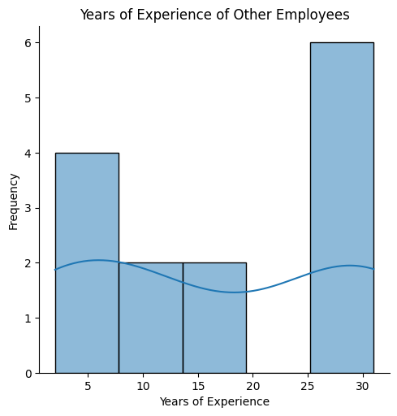

***figure 16. Histogram for Years of Experience of Other Employees rather than Male and Female***

**Explanation:**

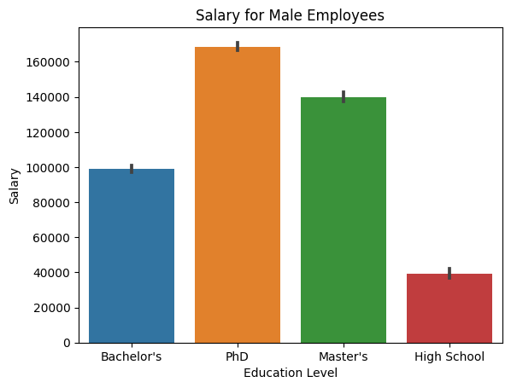

***figure 17. Bar Chart for Salary for Male Employees based on their Education Level***

**Explanation:**

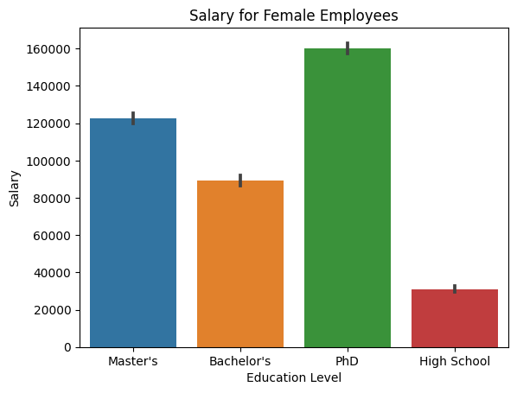

***figure 18. Bar Chart for Salary for Female Employees based on ther Education Level***

**Explanation:**

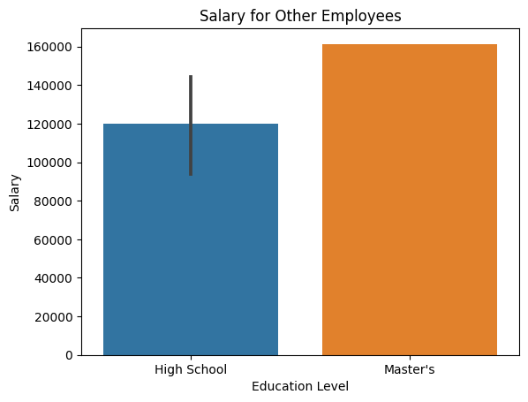

***figure 19. Bar Chart for Salary for Other Employees based on their Education Level***

**Explanation:**

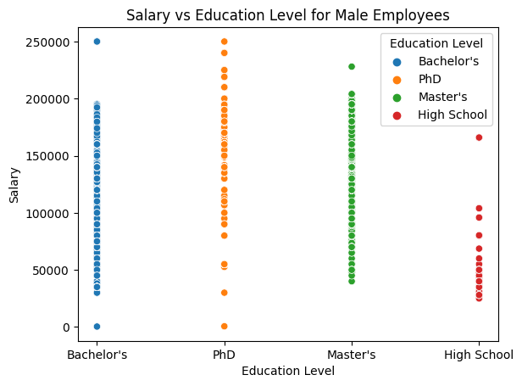

***figure 20. Scatter Plot for Salary vs Education Level for Male Employees***

**Explanation:**

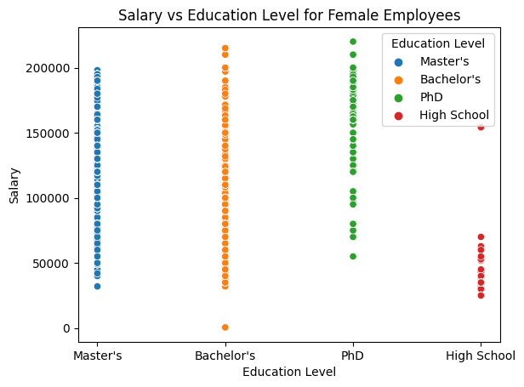

***figure 21. Scatter Plot for Salary vs Education Level for Female Employees***

**Explanation:**

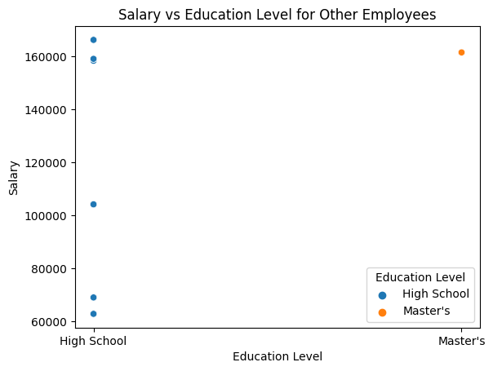

***figure 22. Scatter Plot for Salary vs Education Level for Other Employees***

**Explanation:**

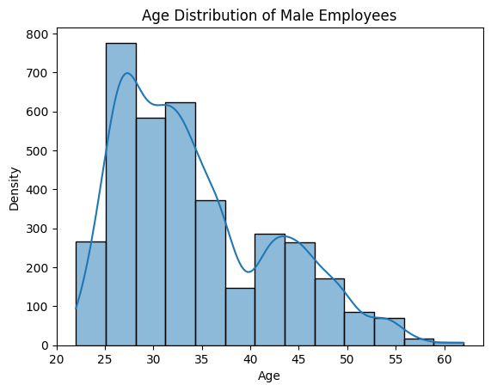

***figure 23. Histogram for Age Distribution of Male Employees***

**Explanation:**

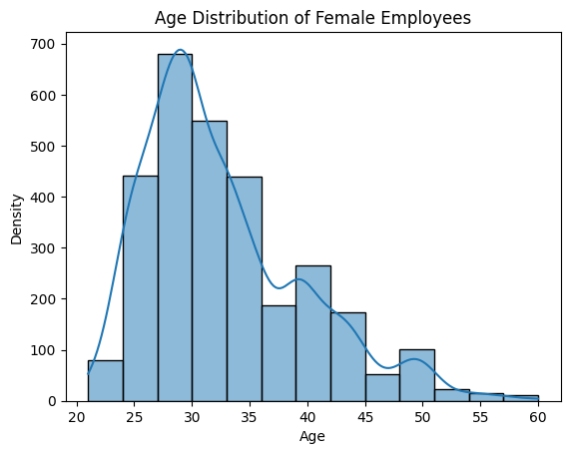

***figure 24. Histogram for Age Distribution of Female Employees***

**Explanation:**

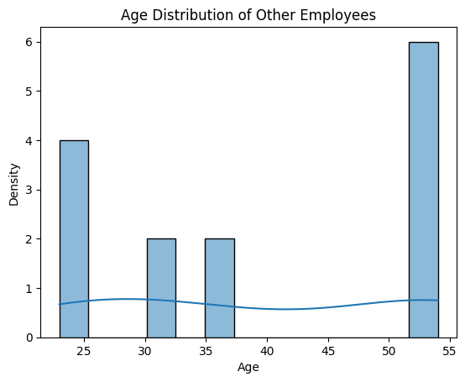

***figure 25. Histogram for Age Distribution of Other Employees***

**Explanation:**

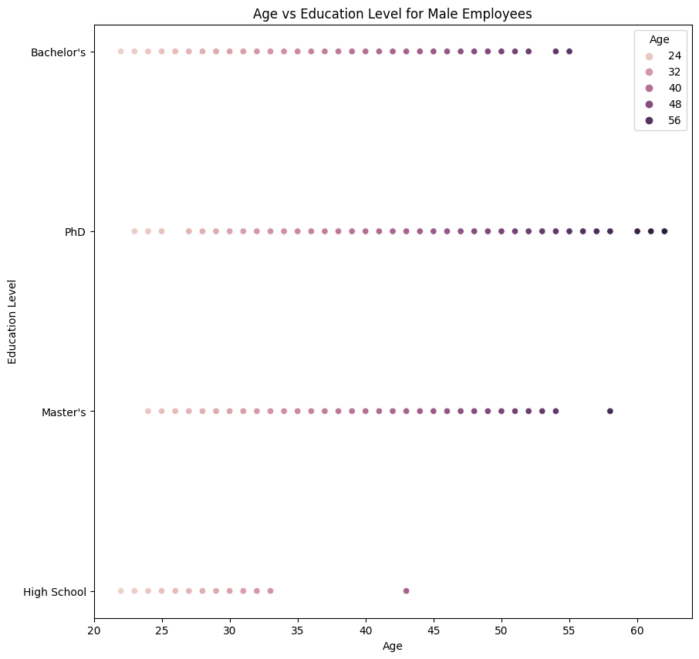

***figure 26. Scatter Plot for Age vs Education Level for Male Employees***

**Explanation:**

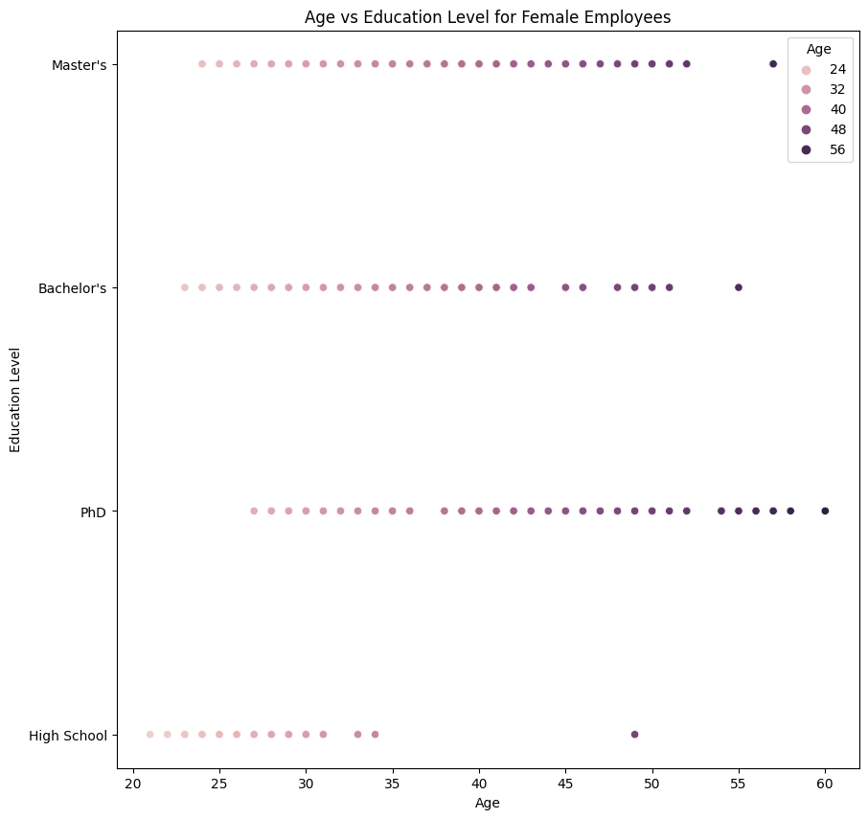

***figure 27. Scatter Plot for Age vs Education Level for Female Employees***

**Explanation:**

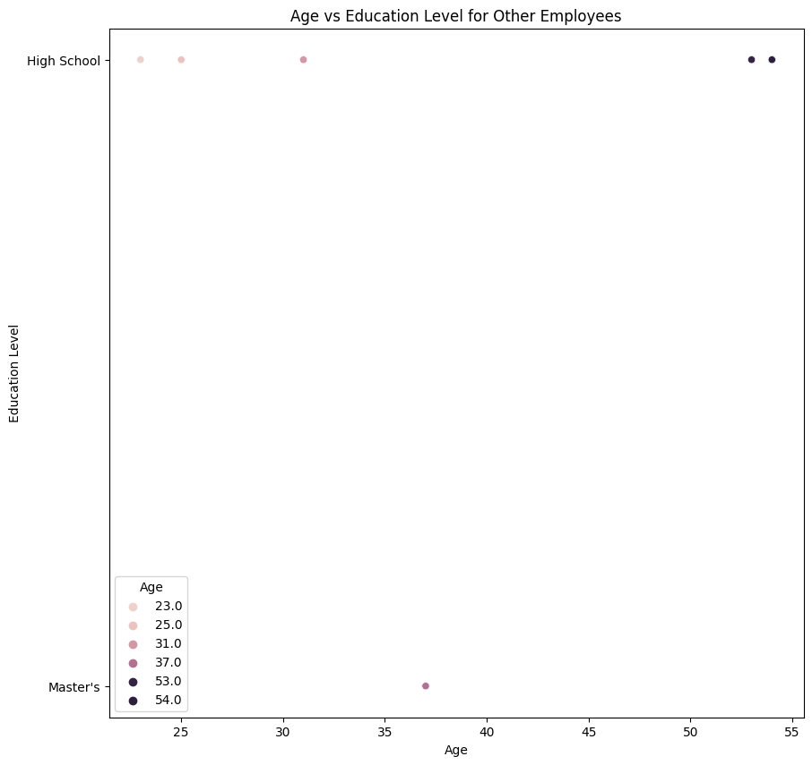

***figure 28. Scatter Plot for Age vs Education Level for Other Employees***

**Explanation:**

# Conclusion

**Link:** [Data Visualization Project - CSE303.ipynb](https://colab.research.google.com/drive/14F1GIP86okuSKC37eDwqtFF9y5_D_dRS?usp=sharing)